Creating a Workplace Where People Want to Be

Step 1: Recognize the Problem: Where Are We Now?
Poll/Survey your staff
- Ask your staff to describe your current workplace culture
- The survey needs to be anonymous
- You can use an outside facilitator, or you can do this internally through a neutral party, the leader.
- Pay attention to being able to provide true anonymity for a small office.

Step 2: Set the Expectation.
Culture is set by the leader.
Call out the problem behavior and be willing to act on it as the leader.
Have the hard conversation and set the expectations for your team.
WALK YOUR TALK.
Be ready for self-assessment and 360-degree feedback if needed.

Step 3: Visioning Exercise: Where do we want to be?
Victory Circle
Visioning Exercise: Victory Circle
Materials: flip chart w/large circle, sticky notes, markers

PROMPT: Imagine our workplace with an ideal culture.
While they are writing…facilitator is giving supportive direction:
Write as many ideas as possible – unfiltered, no idea is a bad idea.
Try to BE SPECIFIC – No generalities like “better communication” but instead try “a weekly update email so we all know what is happening this week, or the status of a project, etc.”
Use descriptive nouns and adjectives.
If you get stuck, try using your senses and describe the workplace.
- What does the workplace look like? What do you see?
- What sounds do you hear?
- What do you feel like in this workplace?
- What do you taste? [these next two may be odd questions, but brings levity…someone might say a warm cup of coffee, or donuts in the breakroom, healthy snacks available, or it smells clean, etc.]
- What do you smell in this workplace?
- How are people behaving differently?
- How are decisions being made?
- How are people working together that is different than before?

Step 4: Establishing your staff’s rules. What are our staff’s expectations for the workplace?
If culture is toxic – hit it head on and lead from the top.
Leadership may need to set the expectations.
Leaders lay out what they are observing and how it us hurting our culture and effectiveness.
Our culture is critical to our success as an organization.
Everyone wants their workplace to be a place they want to be. None of us want to dread coming to work, doing our work, or being with our coworkers. Right now, we are missing the mark as a team.
This is what I expect from each of us moving forward. (Know in your mind what will happen if these expectations are breached).
I’m going to hold you accountable. You’re going to hold me accountable. We are going to hold each other accountable.
Set a plan to touch base regularly in follow up…is it working?

If culture needs a tweak and you want input from the team.
If you poll your staff and there are warning signs (there is always room for improvement), you might choose a team approach to developing your expectations. This way, the team has buy-in in writing their rules and can help operate them.

Establishing your staff expectations/rules.
Your team can go about establishing staff expectations using several different methods.
You might research guided brainstorming processes or nominal group processes to decide what strategy is best for your team. A process can be led by the Executive Director or other members of the leadership team, your HR Manager, or an outside facilitator.

Recommend SIMPLICITY – keep it around 5 easy to understand rules.

If you are going to co-write your staff expectations with your team, then ensure consensus.
A rule does not get on the list without full group consensus:
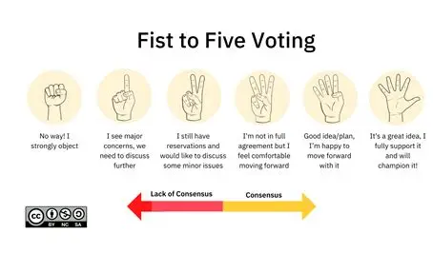
Fist-to-Five Voting for Consensus
To be added to the list of expectations, the idea/statement needs to have at least a 3-finger vote.
0 (fist): No, I strongly object.
1 finger: I see major concerns; we need to discuss further.
2 fingers: I still have reservations and would like to discuss some minor issues.
3 fingers: I am not in full agreement, but I feel comfortable moving forward.
4 fingers: Good idea/plan. I am happy to move forward with it.
5 fingers: It’s a great idea. I fully support and will champion it.

Step 5: Tips to operationalize your plan.
- Print the rules and have staff members sign an agreement to those rules.
- Recommit annually:
  - Review the rules annually at your staff meeting/staff retreat – have staff sign again.
  - Review during staff annual review – have staff sign again.
- Integrate into interviewing and orientation processes
- Add to your Employee Policies

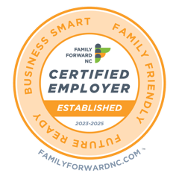
Learn More About Becoming a Family Forward NC Certified Employer: https:familyforwardnc.com

Need help facilitating this work with your team?
Personal: Elisha Childers
Email: elishawchilders@gmail.com
Text/Call: (828) 388-3805
Connect on Linked In: https://www.linkedin.com/in/elishachilders/

At the office:
Elisha Childers
Executive Director
Children’s Council of Watauga County, Inc.
Phone: (828) 262-5424 x 206
Email: elisha@thechildrenscouncil.org
Website: www.thechildrenscouncil.org

